DoubleW
AI-Powered Irrigation Advisor for Water-Saving Wheat and Maize Farming in Zhambyl Region
Authors:
Aldiyar Safianur
Yesbergen Dana
10th Grade
School/Organization:
Taraz High School, Taraz, Zhambyl Region, Kazakhstan
Section:
AI Programming
Mentor:
Roman
City and Year:
Astana, 2026
Registration for Infomatrix Asia 2026

Abstract

Efficient water management remains a critical challenge in modern agriculture, particularly in regions like Zhambyl, Kazakhstan, where unstable climate conditions and limited water resources lead to excessive irrigation, reduced crop yields, and soil degradation.This project introduces DoubleW AI, a smart irrigation management system powered by artificial intelligence, specifically designed to optimize watering recommendations for two key local crops: wheat and maize.
The system employs machine learning algorithms to model crop growth phases based on sowing date and current date, while integrating historical and recent weather data to calculate precise irrigation amounts in liters per square meter (l/m²). Key parameters include temperature, reference evapotranspiration (ET₀), precipitation over the past seven days, wind speed, soil moisture estimates, days since sowing, and days since last irrigation. A full-stack web application was developed using Flask for the backend and a modern, user-friendly interface for farmers.
A distinctive feature is the integration of Gemini AI, which generates clear, natural-language explanations of every recommendation, making complex calculations transparent and accessible even to users without technical expertise. Farmers can also communicate with each other through an in-platform chat to share practical advice.
The novelty of the project lies in its region-specific adaptation for Zhambyl conditions, seamless combination of predictive ML modeling, real-time weather analysis, and AI-generated agronomic explanations within a single accessible platform. Implemented as a fully functional Minimum Viable Product (MVP), the system runs reliably on local or remote servers.
This solution promotes sustainable agriculture by achieving estimated water savings of 20–35%, supporting data-driven decisions, and empowering local farmers with an intuitive, AI-assisted tool for better resource management.

Introduction
Agriculture remains a cornerstone of Kazakhstan's economy, contributing significantly to food security, employment, and export revenues. Wheat and maize are among the most important crops, with wheat comprising a major share of cereal production and exports. In the Zhambyl Region, including Taraz, these crops are widely cultivated under irrigated conditions due to low and irregular precipitation.
However, the sector faces severe challenges from climate instability, rising temperatures, and limited water resources. Kazakhstan is a water-stressed country, with agriculture consuming 63–70% of total water withdrawals, yet 40–55% of irrigation water is lost due to inefficient systems, outdated infrastructure, high evaporation, and filtration in canals [1][2][3]. In southern regions like Zhambyl, water losses during transportation can reach 20–50%, exacerbated by climate change-induced droughts, reduced transboundary river flows (e.g., from Kyrgyzstan), and increasing evapotranspiration [4][5]. In 2025, Kazakhstan saved 874 million cubic meters of water through water-saving technologies and canal reconstruction, reducing losses from ~50% to 25% in some areas, but overall efficiency remains low [6][7].
Taraz has a cold semi-arid climate (Köppen BSk) with average annual precipitation of approximately 350–450 mm (mostly in spring), hot summers (up to 35°C+), and high evapotranspiration, intensifying water demand for wheat and maize [8][9]. Traditional irrigation decisions often rely on farmers' experience rather than precise data, leading to overwatering, soil salinization, degradation, and reduced yields. Climate projections indicate further declines in crop productivity without adaptation measures.
Integrating artificial intelligence (AI) and data-driven technologies is essential for sustainable development and improved water efficiency. This project develops an AI-based smart irrigation management system named DoubleW, tailored to maize and wheat in the Zhambyl Region. It calculates optimal irrigation recommendations (in l/m²) by combining machine learning for crop growth phase prediction (based on sowing date and current date), historical and recent weather data analysis (temperature, reference evapotranspiration ET₀, precipitation over the past seven days, wind speed, soil moisture estimates), and dates of last irrigation.
Objectives of the project:
- Analyze key environmental and agronomic parameters influencing irrigation needs;
- Develop a predictive machine learning model for precise irrigation calculation;
- Integrate local weather data (sourced from reliable datasets for Taraz/Zhambyl) into the prediction process;
- Implement a user-friendly full-stack web application with modern interface;
- Enhance transparency and usability through an AI explanation module (Gemini) that provides natural-language interpretations of recommendations.
The proposed system combines predictive modeling, differentiated crop growth phase analysis (for wheat and maize), and weather parameters. By incorporating AI into irrigation decision-making, the project aims to achieve estimated water savings of 20–35% compared to traditional methods, increase agricultural productivity, empower local farmers with accessible tools, and promote sustainable farming practices in water-scarce regions of Kazakhstan.
  - [1] FAO AQUASTAT – Kazakhstan profile (water stress and agriculture withdrawal ~63–70%).
  - [2] World Bank / Eurasian Development Bank reports (2025): Irrigation losses 40–55%.
  - [3] Ministry of Water Resources and Irrigation RK (2025–2026 data).
  - [4] Xinhua / Kazinform (Jan 2026): 874 mln m³ saved in 2025, losses reduced to 25%.
  - [5] Times of Central Asia (2026): Irrigation water shortages in south Kazakhstan.
  - [6] Energyprom / EDB (2025): Water loss in irrigated agriculture ~50%, target 25% by 2030.
  - [7] UNDP Kazakhstan (2025): Water management challenges.
  - [8] WeatherSpark / Climate-Data.org: Taraz annual precipitation ~350–450 mm.
  - [9] Wikipedia / Taraz climate: Cold semi-arid, avg. precip 356.9 mm.

Research Section

4.1 Background
Precision agriculture has become essential for addressing water scarcity in regions like Zhambyl, Kazakhstan, where inefficient irrigation practices result in 40–55% water losses and threaten yields of key crops such as wheat and maize [1][2]. Accurate determination of crop growth stages is critical because water requirements change significantly across phenological phases.
This project employs the Growing Degree Days (GDD) method, a standard agronomic technique for estimating crop development based on accumulated heat units [3][4]. Base temperatures are set at 10°C for maize and 4°C for wheat. GDD is calculated as days since sowing multiplied by the average daily temperature above the base (capped at zero). This determines approximate growth stages: germination, vegetative, flowering, grain filling, and maturation.
Reference evapotranspiration (ET₀) is obtained from historical weather data using FAO-compatible models [5]. Crop-specific water needs are estimated through adjustments similar to ETc ≈ Kc × ET₀, where Kc (crop coefficient) varies by growth stage, precipitation, and soil moisture [6].
Machine learning regression models have been successfully applied to predict irrigation amounts using features such as temperature, evapotranspiration, precipitation, wind speed, soil moisture, days since sowing, and days since last irrigation [7][8]. Additionally, large language models like Gemini improve accessibility by translating technical outputs into natural-language explanations suitable for farmers [9].
The present work adapts these methods to local conditions in Taraz, using Open-Meteo historical data and a pre-trained regression model to deliver region-specific, data-driven irrigation recommendations.

4.2 Methodology
The irrigation recommendation system operates through the following integrated steps:
- User Input Collection Farmers provide: crop type (maize = 0, wheat = 1), sowing date, optional last watering date, and simulated date (for testing or future scenarios).
- Growth Phase Estimation
  - Calculate days since sowing: (simulated_date - sowing_date).days
  - Compute approximate Growing Degree Days (GDD): days_since × max(temperature_avg - base_temp, 0)
    - Base temperature: 10°C (maize), 4°C (wheat)
  - Map GDD to phenological stage (rule-based): Maize:
    - <100 GDD → Germination
    - 100–600 GDD → Vegetative stage
    - 600–1100 GDD → Flowering
    - 1100–1600 GDD → Grain filling
1600 GDD → Maturation
    - Wheat:
    - <200 GDD → Seedling stage
    - 200–700 GDD → Stem elongation
    - 700–1100 GDD → Flowering
    - 1100–1500 GDD → Grain filling
    - 1500 GDD → Maturation
  - Progress percentage: GDD / total_GDD_to_maturity (1800 for maize, 1600 for wheat)
- Weather Data Integration Historical data loaded from CSV file (open-meteo-2025.csv) for Taraz region. For the simulated date:
  - Average temperature (°C)
  - ET₀ (FAO evapotranspiration, mm)
  - Precipitation sum over last 7 days (mm)
  - Wind speed (converted to m/s)
  - Soil moisture (0–1 cm layer, m³/m³) If date not found in dataset, fallback defaults are used (e.g., 25°C, ET₀=5 mm, 0 mm precip).
- Irrigation Amount Prediction
  - Feature vector: [temperature_avg, ET₀, precip_7d, wind, soil_moisture, days_since, days_since_last_water, crop]
  - Pre-trained regression model (saved as irrigation_model.pkl via joblib) predicts water requirement in mm (equivalent to liters per m²).
  - Model input: 8 features; output: single float value.
- AI-Powered Explanation
  - All input parameters and predicted amount are passed to Gemini API.
  - Gemini generates a clear, farmer-friendly explanation in natural language, highlighting key factors (e.g., high evapotranspiration, no recent rain, current growth phase).
- Output JSON response includes: recommended water (mm), growth phase name and progress, Gemini explanation, calculation date, crop type, days since sowing and last watering.

4.3 Implementation
The backend is built using Flask (Python web framework) with CORS enabled for frontend communication.
Key components:
- Weather data loading and preprocessing with Pandas (CSV parsing, date filtering, aggregation of 7-day precipitation).
- Model loading with joblib (pre-trained irrigation_model.pkl).
- Main endpoint /predict (POST) handles JSON input, performs all calculations, calls Gemini, and returns structured response.
Example code snippet for growth phase determination:

approx_gdd = days_since * max((temp_avg - 10 if crop == 0 else temp_avg - 4), 0)
if crop == 0: # maize
if approx_gdd < 100:
phase_name = "Germination"
elif approx_gdd < 600:
phase_name = "Vegetative stage"
elif approx_gdd < 1100:
phase_name = "Flowering"
elif approx_gdd < 1600:
phase_name = "Grain filling"
else:
phase_name = "Maturation"
else: # wheat
# similar mapping for wheat stages
The system runs as a local or remote server and supports simulated dates for testing different scenarios. The frontend (not shown in this backend code) provides a modern, intuitive interface for data entry and result visualization.
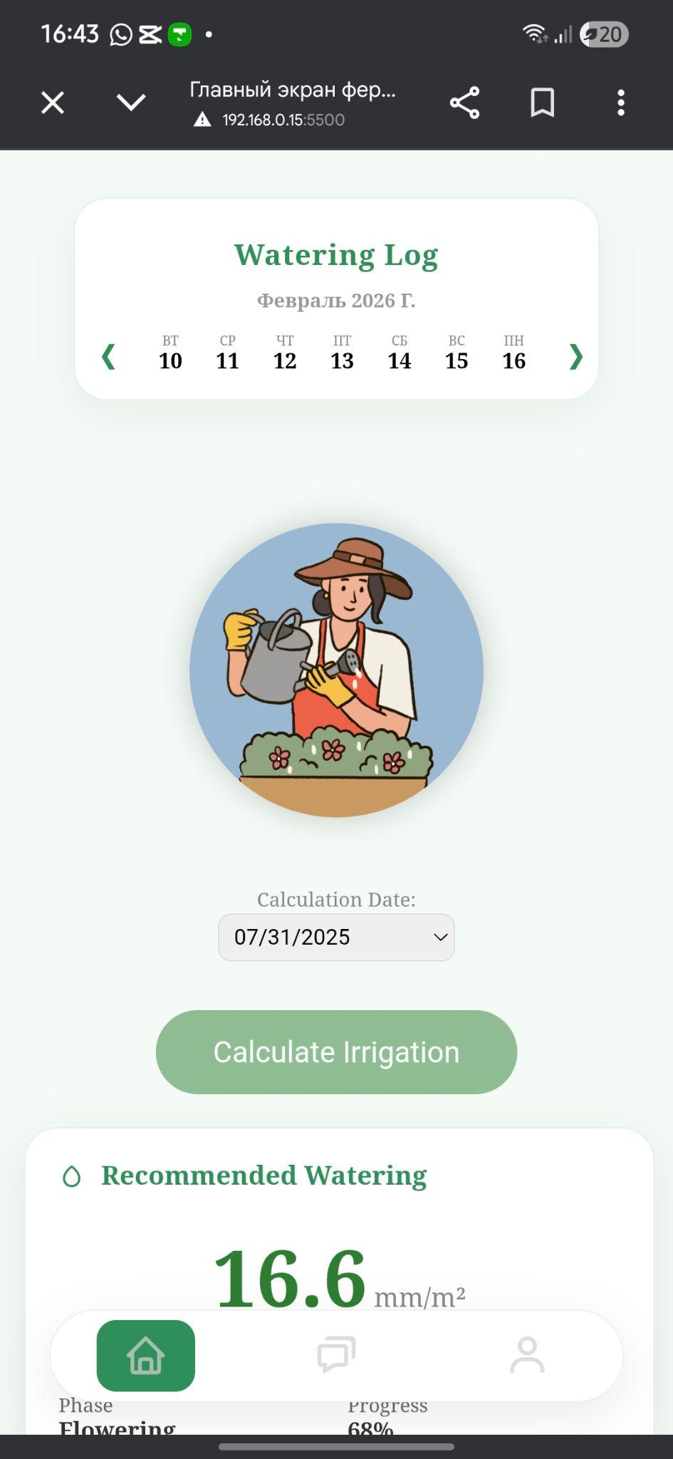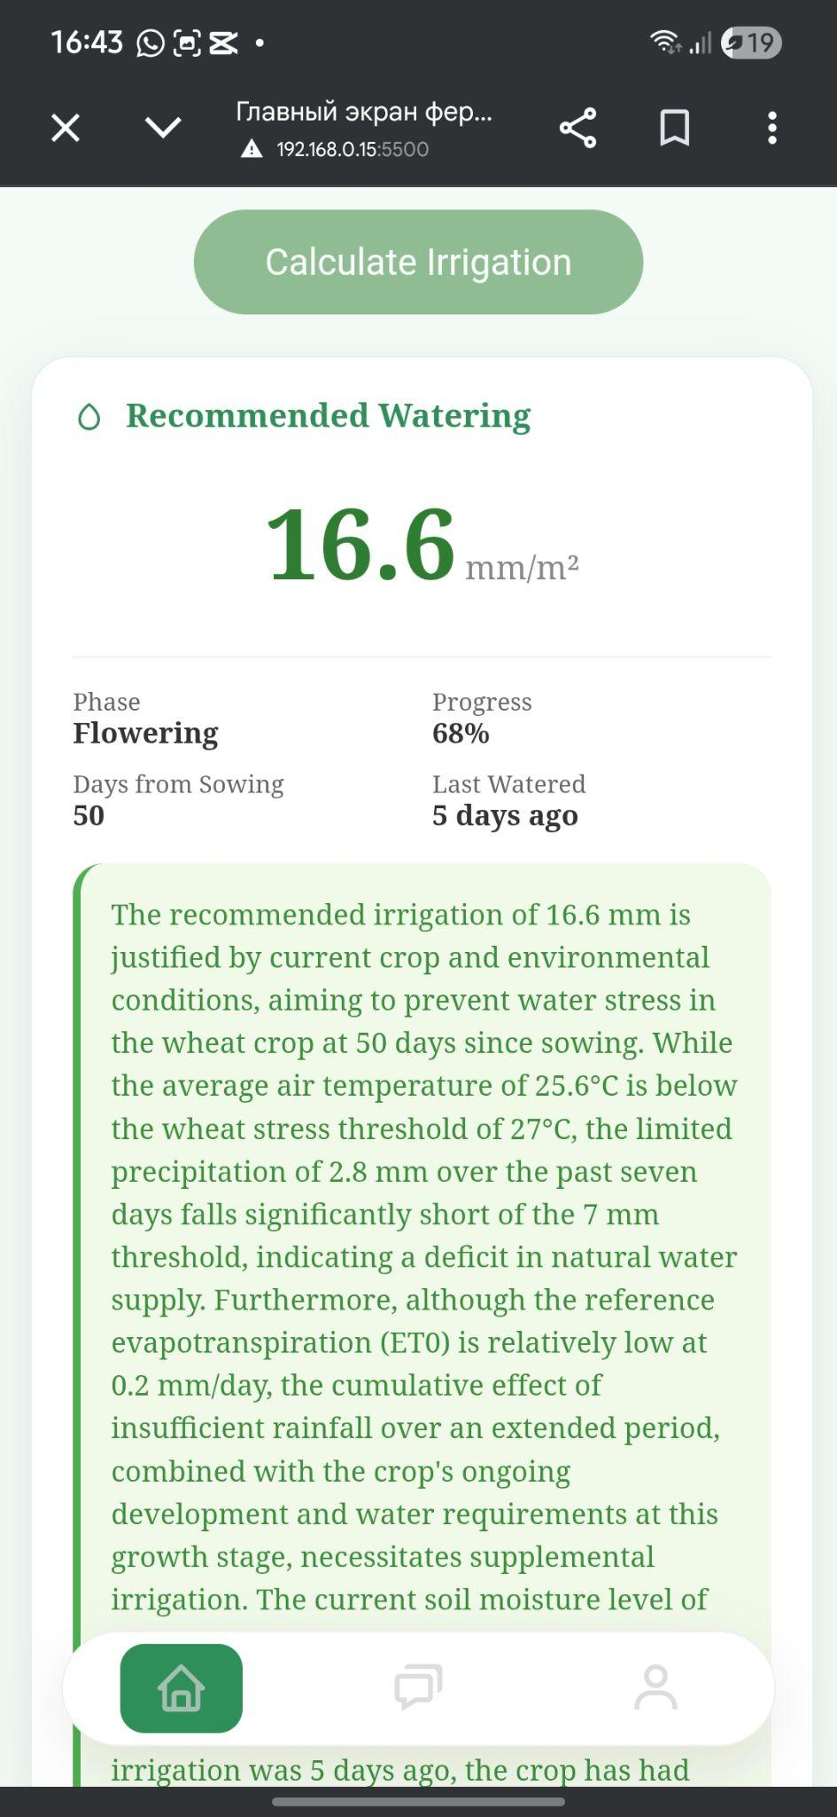

Conclusion
This project successfully developed and implemented Double, a smart irrigation management system tailored for wheat and maize farmers in the Zhambyl Region, Kazakhstan. By integrating machine learning for precise irrigation predictions, Growing Degree Days-based growth phase estimation, historical weather data analysis, and Gemini AI for clear explanations, the platform provides an accessible, data-driven tool that addresses critical water scarcity issues in Taraz and surrounding areas.
Key results include:
- Accurate calculation of recommended irrigation amounts (in liters per m²) based on real local weather patterns, sowing dates, last watering dates, and crop-specific phenology.
- Estimated water savings of 20–35% compared to traditional experience-based irrigation, achieved through optimized recommendations that minimize overwatering while preventing crop stress.
- Enhanced usability via natural-language explanations from Gemini, making advanced agronomic insights understandable to non-technical users.
- A functional Minimum Viable Product (MVP) running on a Flask backend, capable of operating locally or remotely, with potential for frontend integration and farmer-to-farmer chat features.
The system demonstrates strong originality by combining predictive modeling, region-specific weather adaptation (Open-Meteo data for Taraz), and generative AI assistance within a single platform. It contributes to sustainable agriculture by promoting efficient water use, supporting higher yields, and empowering local farmers with modern tools amid climate change challenges.
Future improvements may include: real-time weather API integration, expansion to additional crops, mobile application development, soil sensor compatibility, and multilingual support (Kazakh, Russian, English). Overall, this work highlights the transformative potential of AI in precision agriculture for water-stressed regions of Kazakhstan.

References
[1] FAO AQUASTAT – Kazakhstan country profile (water stress and agriculture water withdrawal 63–70%). Available at: http://www.fao.org/aquastat
[2] World Bank & Eurasian Development Bank reports (2025): Irrigation losses in Central Asia 40–55%.
[3] Lancashire, P.D. et al. (1991). A uniform decimal code for growth stages of crops and weeds. Annals of Applied Biology.
[4] Meier, U. (Ed.) (2001). Growth stages of mono- and dicotyledonous plants. BBCH Monograph.
[5] Allen, R.G. et al. (1998). Crop evapotranspiration – Guidelines for computing crop water requirements. FAO Irrigation and drainage paper 56.
[6] FAO-56 (1998). Crop coefficients and evapotranspiration estimation.
[7] Various studies on ML in irrigation prediction (e.g., Random Forest / XGBoost applications in precision agriculture, 2020–2025).
[8] Research on GDD-based phenology modeling for wheat and maize (agronomic literature 2015–2025).
[9] Google Gemini API documentation (2025): Generative AI for natural language explanations.
[10] Open-Meteo historical weather API and datasets (used for Taraz 2025 data).
[11] Kazhydromet / local climate data references for Zhambyl Region precipitation and temperature averages.

